

**Table of Contents**

1 Objective of This Experiment 3

2 The One-Phase Full Wave Rectifier 3

2.1 Waveforms of voltages and currents at α = 90 4

2.2 Harmonic spectrums of the input/output currents and voltages at α = 90 5

3 The Three-Phase Full Wave Rectifier 7

3.1 Waveforms of voltages and currents at α = 60 8

3.2 Harmonic spectrums of the input/output currents and voltages at α = 60 8

4 Calculations and Questions 10

4.1 The One-Phase Full Wave Rectifier 10

4.2 The Three-Phase Full Wave Rectifier 12

5 Conclusions 14

**List of Figures**

Figure 1:- The figure shows a single phase full-wave controlled rectifier and the load 3

Figure 2:- The figure shows the waveforms of the input/output voltage and current at α =90 4

Figure 3:- The figure shows the harmonics of the input current at α =90 5

Figure 4:- The figure shows the harmonics of the output current at α =90 5

Figure 5:- The figure shows the harmonics of the input voltage at α =90 6

Figure 6:- The figure shows the harmonics of the output voltage at α =90 6

Figure 7:- The figure shows a three phase full-wave controlled rectifier and the load 7

Figure 8:- The figure shows the waveforms of the input/output voltage and current at α =60 8

Figure 9:- The figure shows the harmonics of the input current at α =60 8

Figure 10:- The figure shows the harmonics of the output current at α =60 9

Figure 11:- The figure shows the harmonics of the input voltage at α =60 9

Figure 12:- The figure shows the harmonics of the output voltage at α =60 10

Figure 13:- The figure shows a plot between the firing angle and the output voltage 11

Figure 14:- The figure shows a plot between the firing angle and the power factor 11

Figure 15:- The figure shows a plot between the firing angle and the efficiency 12

Figure 16:- The figure shows a plot between the firing angle and the output voltage 13

Figure 17:- The figure shows a plot between the firing angle and the power factor 13

Figure 18:- The figure shows a plot between the firing angle and the efficiency 14

**List of Tables**

Table 1:- The table shows the data for the single phase full-wave controlled rectifier 4

Table 2:- The table shows the data for the three phase full-wave controlled rectifier 7

# 1 Objective of This Experiment

The aim of this experiment was to examine the performance of the single and three phase full-wave controlled (thyristor-based) rectifiers when supplying to different load types. The performance measures considered include; the harmonics on the input/output side of the converter, the input power factor, the controllability of the output voltage, and the efficiency. The AC-DC bridge of the single and three phase controlled rectifiers were constructed using the AC-DC converter module. The firing angle are generated by the firing angle module.

# 2 The One-Phase Full Wave Rectifier

The figure below shows the circuit for the one phase full-wave controlled rectifier and the resistor. For this experiment, we used an input voltage of 60V with a load of 200 ohm. The data acquisition module (DAM) was used to observe and record; the input current, active power, reactive power, and also the output DC voltage, current and active power. We took the above recordings at different firing angles; 0, 30, 60, 90, 120, 150, and 180; the table below shows a summary of the recorded and calculated data. At α = 90, we observed and recorded the waveforms of the input/output currents and voltages as well as their harmonic spectrum.

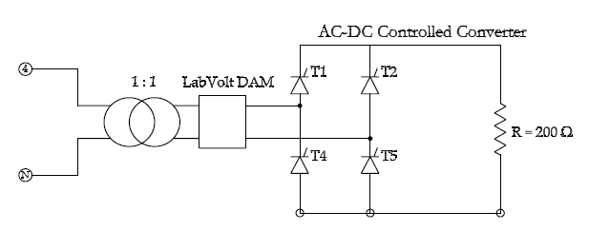

Figure 1:- The figure shows a single phase full-wave controlled rectifier and the load

|  |  |  |  |  |  |  |  |  |  |
| --- | --- | --- | --- | --- | --- | --- | --- | --- | --- |
| α | (IA)rms | Pin | Qin | Vdc | Idc | Pdc | PF | HF | η |
| 0 | 0.291 | 17.35 | -0.020 | 51.93 | 0.248 | 16.15 | 1.0000 | 4.5 | 0.9308 |
| 30 | 0.287 | 16.83 | 1.415 | 48.18 | 0.229 | 15.70 | 0.9965 | 15.2 | 0.9329 |
| 60 | 0.262 | 14.09 | 4.304 | 39.38 | 0.184 | 13.07 | 0.9564 | 35.3 | 0.9276 |
| 90 | 0.205 | 8.744 | 5.45 | 25.2 | 0.115 | 8.117 | 0.8487 | 55.8 | 0.9283 |
| 120 | 0.129 | 3.826 | 3.777 | 11.44 | 0.045 | 3.112 | 0.7116 | 74.1 | 0.8134 |
| 150 | 0.053 | 1.203 | 0.780 | 1.255 | -0.004 | 0.530 | 0.8391 | 90.3 | 0.4406 |
| 180 | 0.021 | 1.039 | -0.515 | -2.847 | -0.025 | 0.096 | 0.8960 | 45.2 | 0.0924 |

Table 1:- The table shows the data for the single phase full-wave controlled rectifier

## 2.1 Waveforms of voltages and currents at α = 90

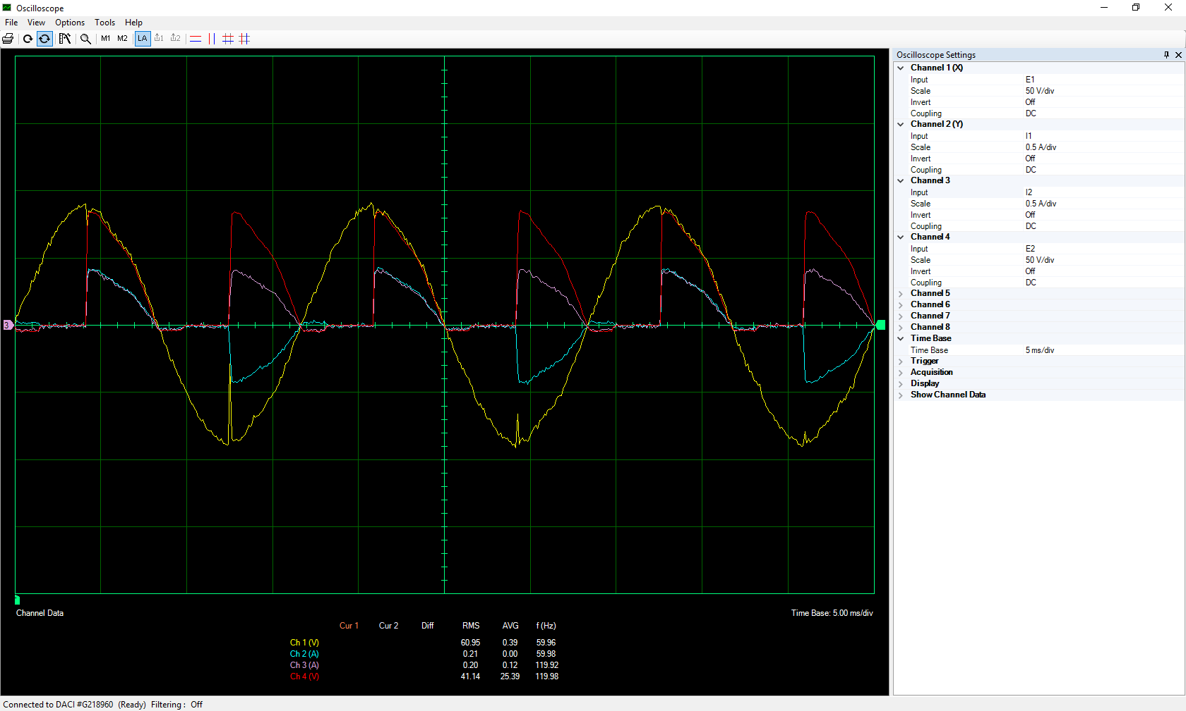*Figure 2:- The figure shows the waveforms of the input/output voltage and current at α =90*

## 2.2 Harmonic spectrums of the input/output currents and voltages at α = 90

*Figure 3:- The figure shows the harmonics of the input current at α =90*

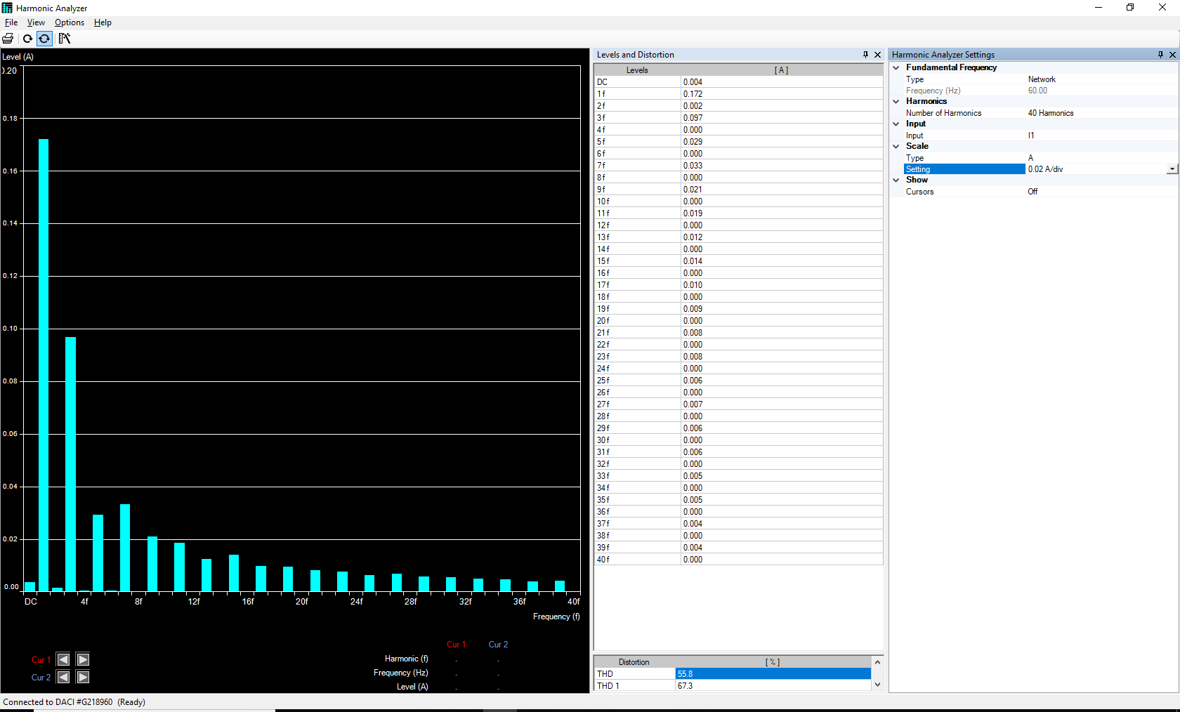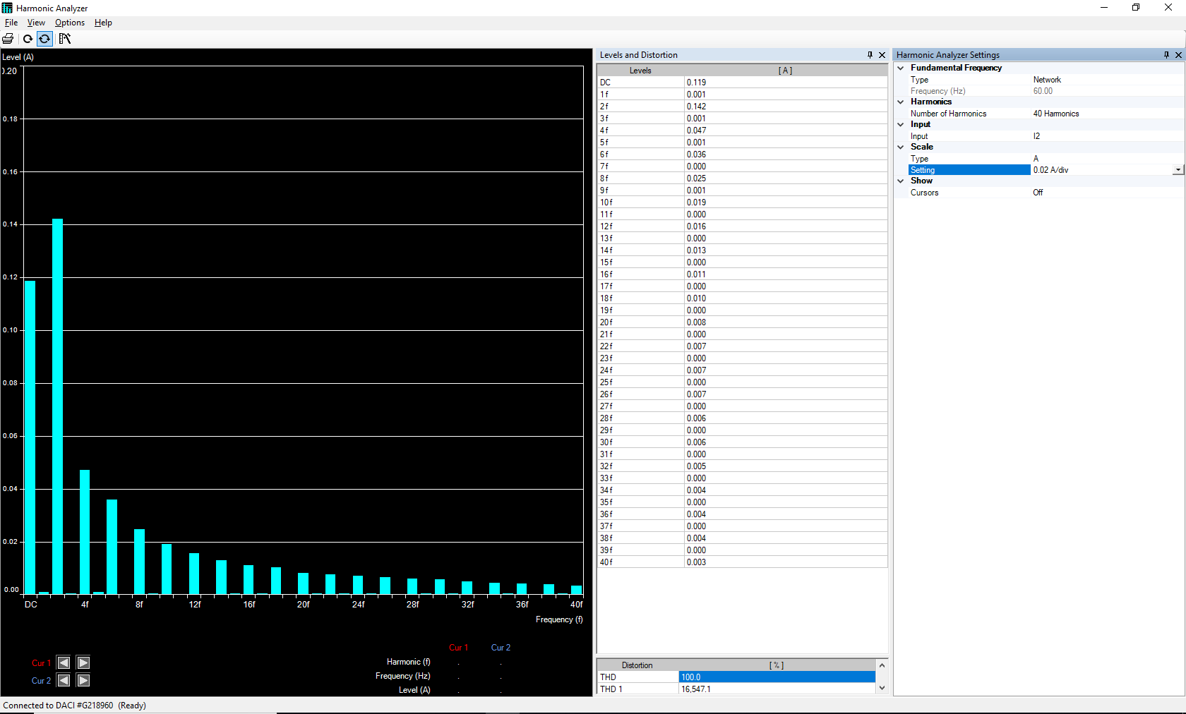

Figure 4:- The figure shows the harmonics of the output current at α =90

*Figure 5:- The figure shows the harmonics of the input voltage at α =90*

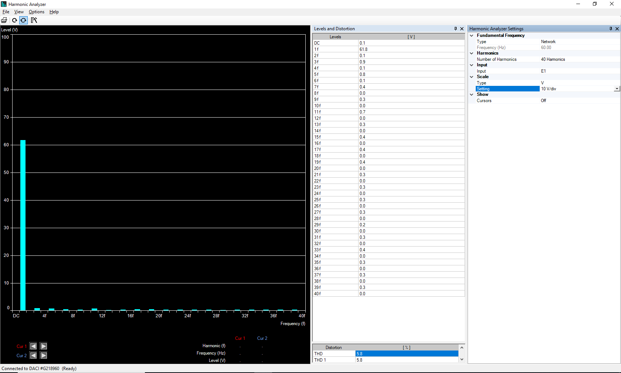

*Figure 6:- The figure shows the harmonics of the output voltage at α =90*

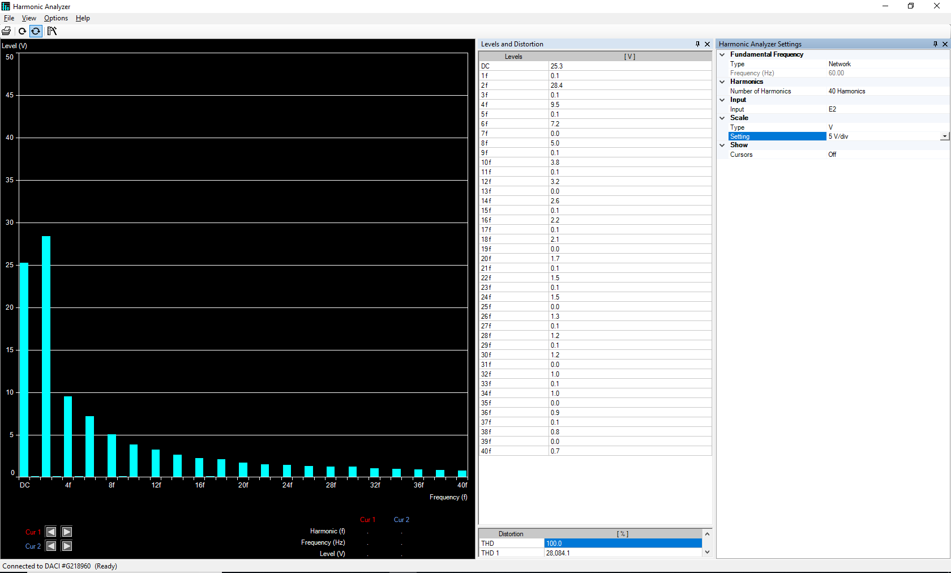

# 3 The Three-Phase Full Wave Rectifier

The figure below shows the circuit for the three phase full-wave controlled rectifier and the DC machine. For this experiment, we used an input voltage of 100V and the DC machine. The data acquisition module (DAM) was used to observe and record; the input current, active power, reactive power, and also the output DC voltage, current and active power. We took the above recordings at different firing angles; 0, 30, 60, 90, and 120; the table below shows a summary of the recorded and calculated data. At α = 60, we observed and recorded the waveforms of the input/output currents and voltages.

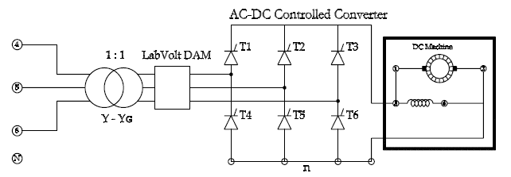*Figure 7:- The figure shows a three phase full-wave controlled rectifier and the load*

|  |  |  |  |  |  |  |  |  |  |
| --- | --- | --- | --- | --- | --- | --- | --- | --- | --- |
| α | (IA)rms | (Pin)3Ø | (Qin)3Ø | Vdc | Idc | Pdc | PF | HF | Η |
| 0 | 0.943 | 296.97 | 31.11 | 237.3 | 1.133 | 268.0 | 0.9946 | 28.2 | 0.9024 |
| 30 | 0.909 | 248.01 | 126.84 | 209.7 | 1.035 | 219.4 | 0.8903 | 40.1 | 0.8846 |
| 60 | 0.691 | 112.89 | 157.2 | 128.0 | 0.735 | 98.29 | 0.5833 | 56.4 | 0.8707 |
| 90 | 0.554 | 14.454 | 154.11 | 5.545 | 0.584 | 6.46 | 0.0934 | 100.0 | 0.4469 |
| 120 | 0.022 | 3.915 | -4.686 | -0.250 | -0.029 | 0.009 | 0.6412 | 100.0 | 0.0023 |

Table 2:- The table shows the data for the three phase full-wave controlled rectifier

## 3.1 Waveforms of voltages and currents at α = 60

*Figure 8:- The figure shows the waveforms of the input/output voltage and current at α =60*

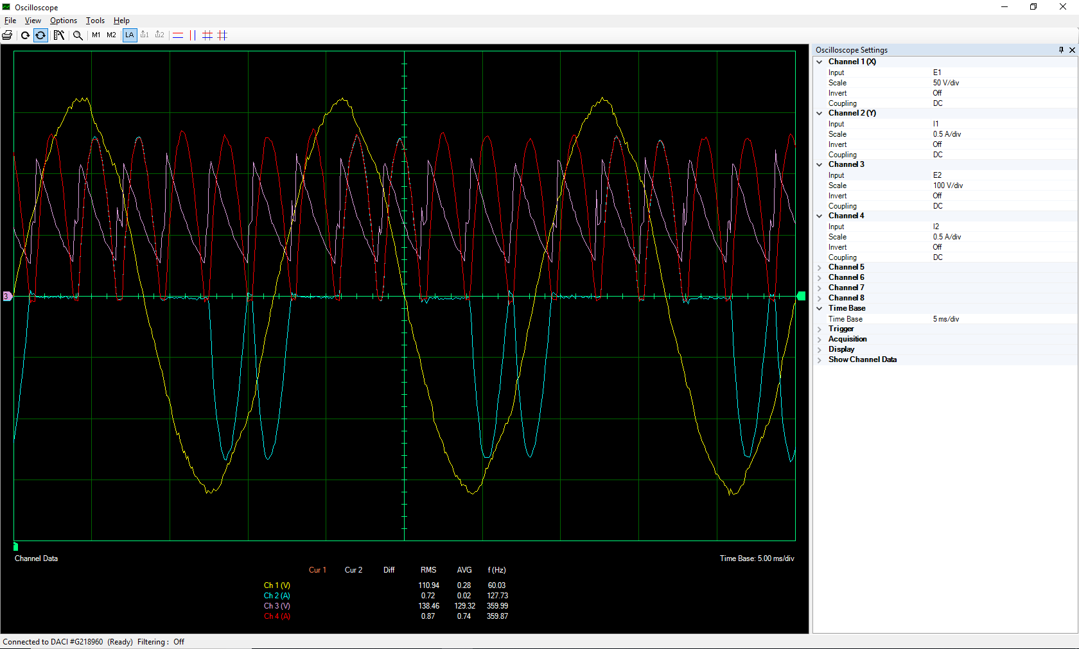

## 3.2 Harmonic spectrums of the input/output currents and voltages at α = 60

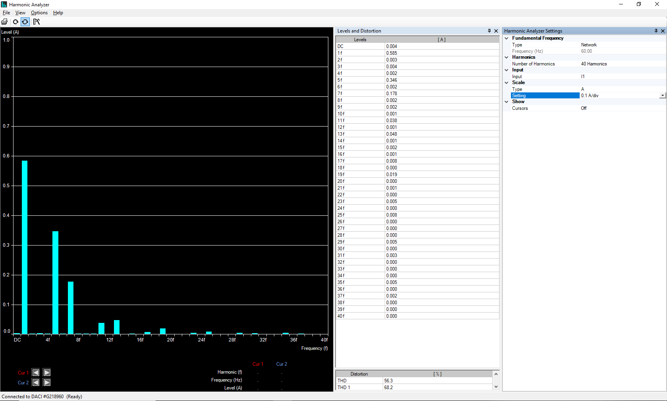*Figure 9:- The figure shows the harmonics of the input current at α =60*

*Figure 10:- The figure shows the harmonics of the output current at α =60*

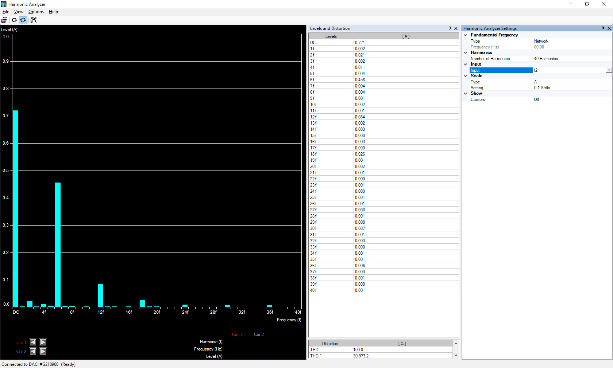

*Figure 11:- The figure shows the harmonics of the input voltage at α =60*

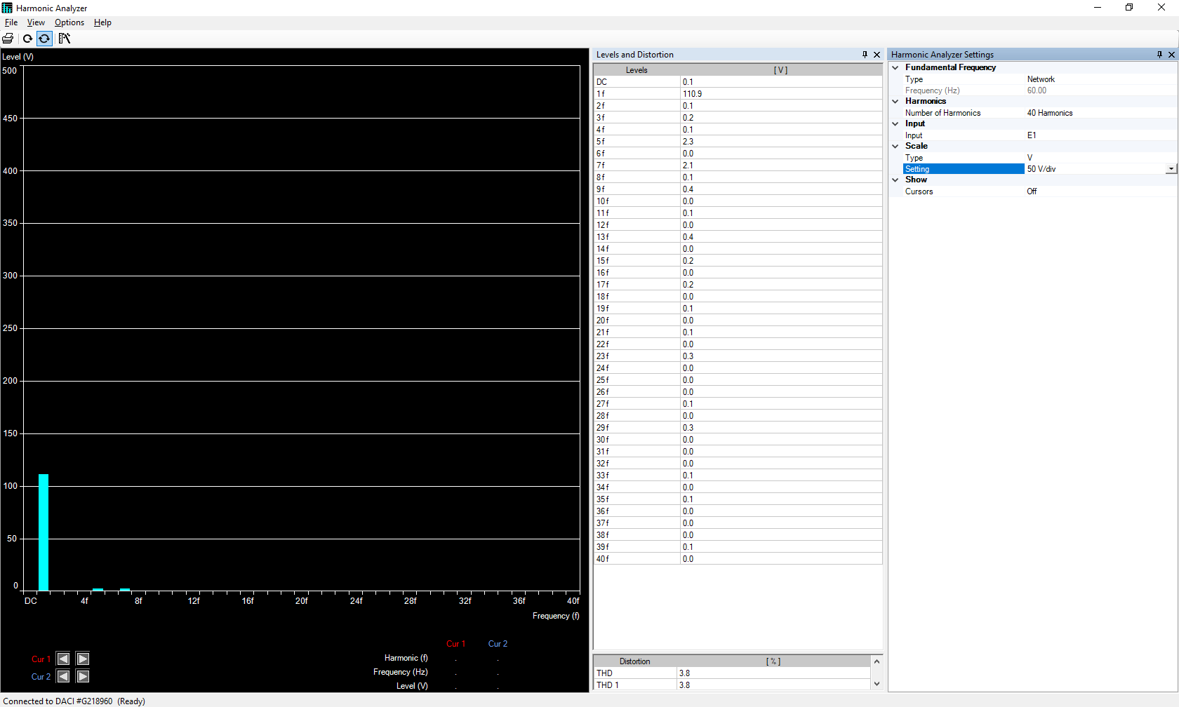

*Figure 12:- The figure shows the harmonics of the output voltage at α =60*

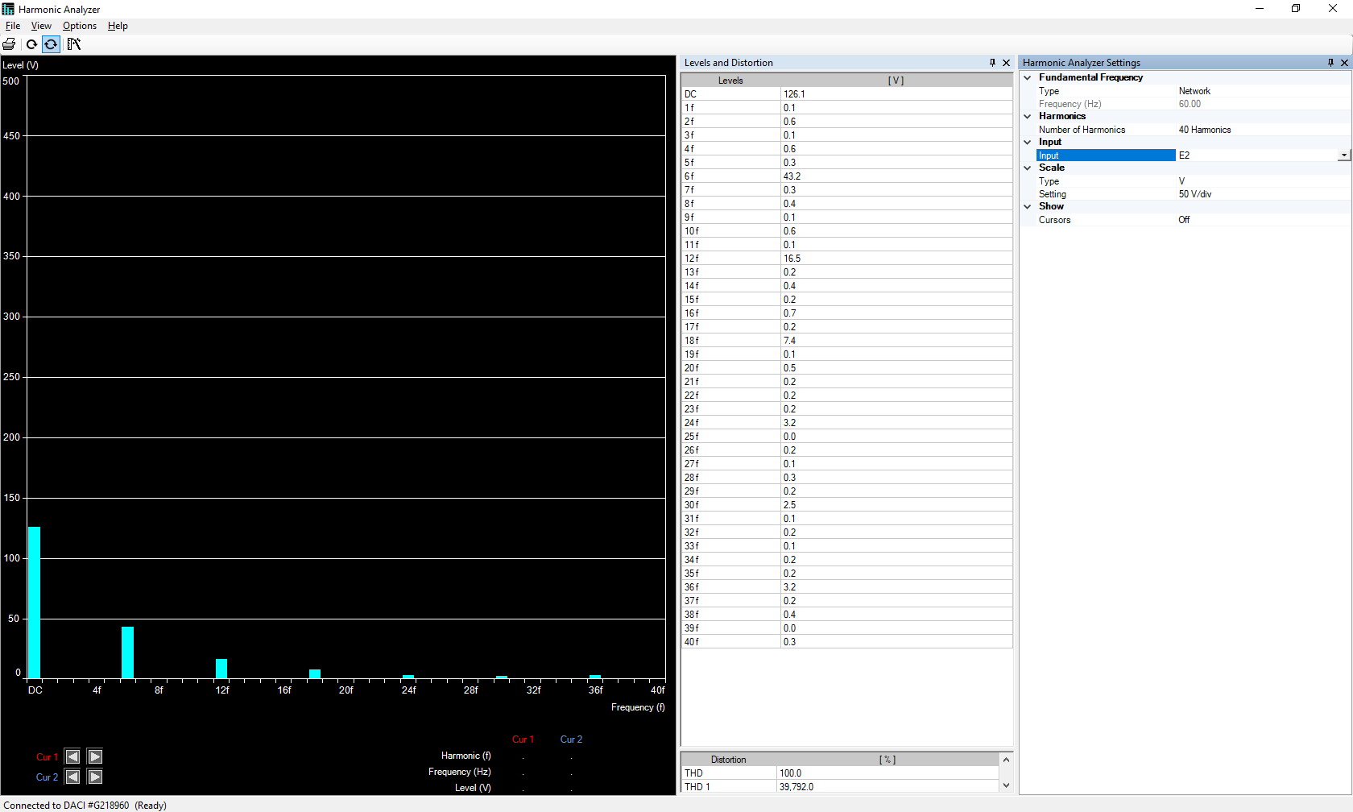

# 4 Calculations and Questions

## 4.1 The One-Phase Full Wave Rectifier

Based on the data gotten from Table 1 above, we can create figures to observe the relationships between the firing angle and the output voltage, power factor, as well as the efficiency.

Figure 13:- The figure shows a plot between the firing angle and the output voltage

From the figure above we can observe that an increase in the firing angle leads to a decrease in the output voltage because the duration of conduction by the thyristors will be decreased; and at a firing angle of 150, the output voltage is close to zero.

Figure 14:- The figure shows a plot between the firing angle and the power factor

From the figure above; we can observe a very good power factor until we reached a firing angle of 60, where there was a decrease in the power factor until we reached a firing angle of 120. We can also observe that there is an increase in the power factor as we cross past a firing angle of 120.

Figure 15:- The figure shows a plot between the firing angle and the efficiency

From the figure above; we can observe that the efficiency experiences an extreme drop as it crosses a firing angle of 90, this drop continued until we had an efficiency below 10% at a firing rate of 180.

## 4.2 The Three-Phase Full Wave Rectifier

Based on the data gotten from Table 2 above, we can create figures to observe the relationships between the firing angle and the output voltage, power factor, as well as the efficiency.

Figure 16:- The figure shows a plot between the firing angle and the output voltage

From the figure above; we can observe that an increase in the firing angle leads to a decrease in the output voltage. We can see a sudden drop in the output voltage after we crossed a firing angle of 60; the DC motor stopped running when we reached a firing angle of 90.

Figure 17:- The figure shows a plot between the firing angle and the power factor

From the figure above; we can observe that an increase in the firing angle leads to a decrease in the power factor, which can be observed until we reached a firing angle of 90. When our firing angle crossed 90; the voltage became almost zero, the DC motor stopped running, and there was no inductive load. This led to an increase in the power factor.

Figure 18:- The figure shows a plot between the firing angle and the efficiency

From the figure above; we can observe that when we reached a firing angle of 60, the efficiency experienced a drastic decrease. This is expected because there was a drastic decrease in our voltage and motor speed as the firing angle was increased.

# 5 Conclusions

In this experiment, we treated two different cases for a full wave controlled rectifier. The first case was with the 200 ohm resistor and the second was with the DC motor. From the figures above, we can see that the firing angle plays a significant role in AC-DC rectification. We can conclude that by lowering the firing angle we would have the best results for the power factor and the efficiency; increasing the firing angle led to an increase in harmonics which in turn reduces the efficiency.